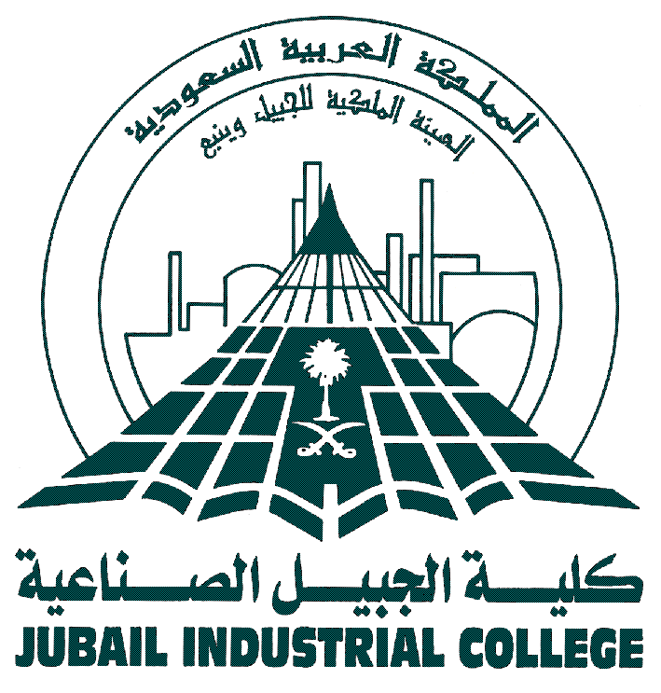 | ROYAL COMMISSION FOR JUBAIL & YANBU  Jubail Industrial College  Associate (Bachelor) of Science Degree Requirements  Name of the major  [Four letter acronym of the major]
1st YEAR LEVEL I
Course code | Course title | Lec | Lab | Credit | CSELH | Pre-req

TOTAL

1st YEAR LEVEL II
Course code | Course title | Lec | Lab | Credit | CSELH | Pre-req

TOTAL

2nd YEAR LEVEL I
Course code | Course title | Lec | Lab | Credit | CSELH | Pre-req

TOTAL

2nd YEAR LEVEL II
Course code | Course title | Lec | Lab | Credit | CSELH | Pre-req

TOTAL

 | Cooperative Work Experience |  |  |  | -

Total credit hours
Students are required to take a technical elective course in the 2nd year level II program.

Associate (Bachelor) of Science in

Name of the major
[Four letter acronym of the major]
LIST OF ELECTIVES
Course code | Course title | Lec | Lab | Credit | CSELH | Pre-req

Total Number of Credits | Total Number of Contact Hours (LT) | Total Number of Contact Hours (LB) | Total Number of Program Effective Learning Hours (PELH)

Approved by:  _______________________  Department Chairman/ Chairman  of the Assigned Committee | Dated:  ______________________

